Dr. D. Y. Patil Institute of Management and Entrepreneur Development



Software Requirements Specification On
“COLLEGE NOTES MANAGEMENT SYSTEM”

Submitted By
Mr. Vishal Dnyaneshwar Sawai

Guided By
Prof. Harini Pawar

Submitted To
Dr. D. Y. Patil Institute of Management and Entrepreneur Development
Varale, Talegaon, Pune

INDEX

ACTIVITY  NO | DESCRIPTION | PAGE NO
1 | 1. Introduction  1.1 Purpose  1.2 Document Conventions  1.3 Product Scope  1.4 References | 3  3  3  3
2 | 2. Overall Description  2.1 Product Perspective  2.2 Product Functions  2.3 User Classes and Characteristics  2.4 Operating Environment  2.5 Design and Implementation Constraints  2.6 Assumptions and Dependencies | 4  4  4  5  5  5
3 | 3. External Interface Requirements  3.1 User Interfaces  3.2 Hardware Interfaces  3.3 Software Interfaces  3.4 Communications Interfaces | 7  7  7  7
4 | 4. System Features  4.1 Functional Requirement  4.2 Use-Case Diagram  4.3 ER – Diagram  4.4 Data Dictionary | 8  9  10  11
5 | - Other Non-functional Requirements  5.1 Performance Requirements  5.2 Safety Requirements  5.3 Security Requirements  5.4 Software Quality Attributes | 13  13  13  13

1. INTRODCUTION

1.1 Purpose

The purpose of this document is to provide a detailed description of the College Notes Management System web application. The application is designed to enable students to access notes provided by their teachers, and to manage those notes in an efficient and organized manner. Only authorized teachers will be able to upload notes to the system, and students will only have access to the notes that have been uploaded by their teachers.

1.2 Document Convections
This Document was created based on the IEEE template for System Requirement
Specification Documents.

1.3 Product Scope
The College Notes Management System web application will provide students with the following features:
- Access to notes provided by their teachers
- Ability to organize notes by class, topic, and date
- Ability to search for specific notes
- Ability to download notes
- Only authorized teachers will be able to upload notes to the system
- Students will only have access to the notes that have been uploaded by their teachers

1.4 References
- IEEE 830-1998, IEEE Recommended Practice for Software Requirements Specifications

2. OVERALL DESCRIPTION

2.1 Product Perspective
The College Notes Management System web application is a web-based application that will be accessible to students via a web browser. The application will be hosted on a server that is maintained by the college.

2.2 Product Functions
The College Notes Management System web application will provide the following functions:
- Upload Notes: Teacher will be able to upload notes
- Access to notes provided by teachers: Students will be able to access notes provided by their teachers through the application.
- Organizing notes: Students will be able to organize their notes by class, topic, and date.
- View notes: Student will be able to view notes
- Download notes: Students will be able to download notes

2.3 User Classes and Characteristics
Student Users
The primary users of the College Notes Management System web application will be students who are enrolled in classes at the college or university. This students will use the application to access notes provided by their teachers, organize their notes by class, topic, and date, search for specific notes.
Characteristics of Student Users
- The students will have a need to access notes provided by their teachers.
- The students will have a need to organize their notes by class, topic, and date.
- The students will expect a user-friendly interface that is easy to navigate.
- The students will expect the application to be accessible on any device with internet access.
- The students will expect the application to be secure and protect their privacy.
Teacher Users
The secondary users of the College Notes Management System web application will be the teachers who are responsible for providing the notes to the students. These teachers will have varying levels of technical expertise, but all will have access to a web browser. The teachers will use the application to upload notes to the system and monitor the access of the students to the notes.
Characteristics of Teacher Users
- The teachers will have a need to upload notes to the system.
- The teachers will have a need to monitor the access of the students to the notes.
- The teachers will expect a user-friendly interface that is easy to navigate.
- The teachers will expect the application to be secure and protect their privacy.
- The teachers will expect the application to be easy to use and understand.
- The teachers will expect the application to be efficient in uploading and monitoring the notes.

2.4 Operating Environment
The College Notes Management System web application will be accessible via a web browser on any device with internet access. The application will be hosted on a server that is maintained by the college.

2.5 Design and Implementation Constraints
The College Notes Management System web application must adhere to the following constraints:
- The application must be accessible via a web browser on any device with internet access.
- The application must be hosted on a server that is maintained by the college
- Only authorized teachers allow to upload notes to the system
- Only authorized student allows to access to the notes that have been uploaded by their teachers

2.6 Assumptions and dependencies
Assumptions
- The College Notes Management System web application will be accessible via a web browser on any device with internet access.
- The students will have access to a web browser and internet access in order to use the application.
- The college or university will maintain a server to host the application and database.
- The teachers will upload notes to the application in a timely manner.
Dependencies
- The College Notes Management System web application will depend on a server to host the application and database.
- The application will depend on a web server software, such as Apache or Microsoft IIS, to function.
- The application will depend on a database to store and retrieve notes.
- The application will depend on internet access for students to access the application and for the application to communicate with the server and database.
- The application will depend on teachers uploading notes in order for students to access them through the application.

3. External Interface Requirements

3.1 User Interfaces
The College Notes Management System web application will have a user-friendly interface that is easy to navigate. The interface will be designed to be responsive and accessible on any device with internet access. The user interface (UI) for a college notes management system can be divided into three main categories: the student interface, administrator interface and teacher interface. The interfaces could be designed using HTML, CSS, and JavaScript, and should be visually pleasing and easy to navigate

3.2 Hardware Interfaces
The College Notes Management System web application will require internet access to function. The application will be hosted on a server that is maintained by the college or university.

3.3 Software Interfaces
The College Notes Management System web application will be accessible via a web browser. The application will be hosted on a server that is running a web server software, such as Apache or Microsoft IIS.

3.4 Communication Interfaces
The College Notes Management System web application will communicate with a database in order to store and retrieve notes. The database will be hosted on a server that is maintained

4. System Features

4.1 Functional Requirement
Functional requirements for a CNMS include:
USER MANAGEMENT: The system should allow for the creation, management, and deletion of user accounts for students, teachers, and administrators. It should also include features for password recovery and security.
STUDENT MANAGEMENT: The system should allow administrators to view, update, and delete student information, such as personal details and academic.
TEACHER MANAGEMENT: The system should allow administrators to view, update, and delete teachers’ information, such as personal details and academic.
NOTES MANAGEMENT: The system should provide the ability to upload and store notes
EMAILS MANAGEMENT: The system should provide the ability send email to students, teacher and administrators related authentication details and many more

4.2 Use Case Diagram

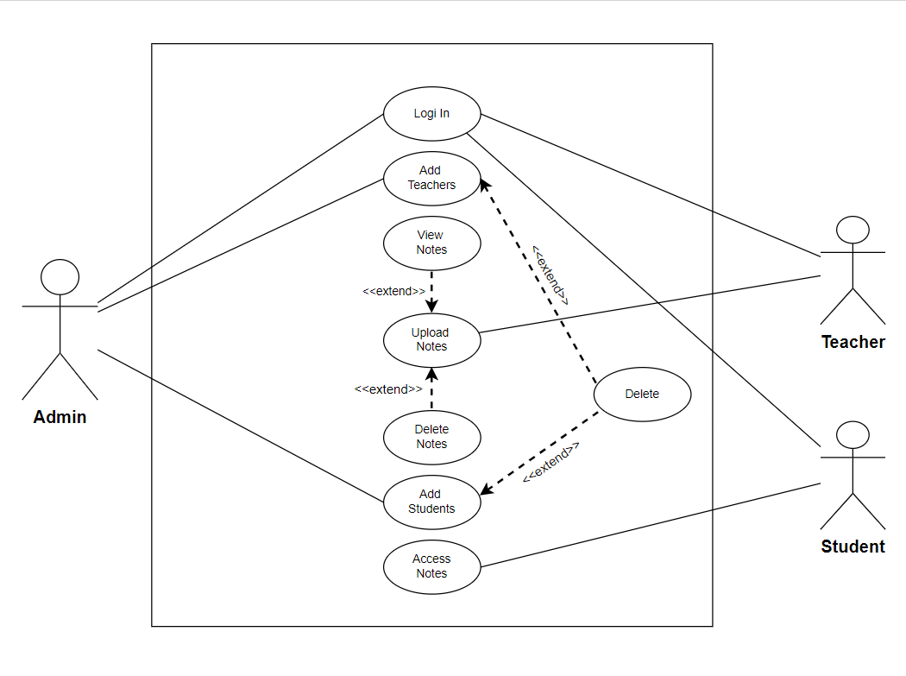

4.3 ER – Diagram

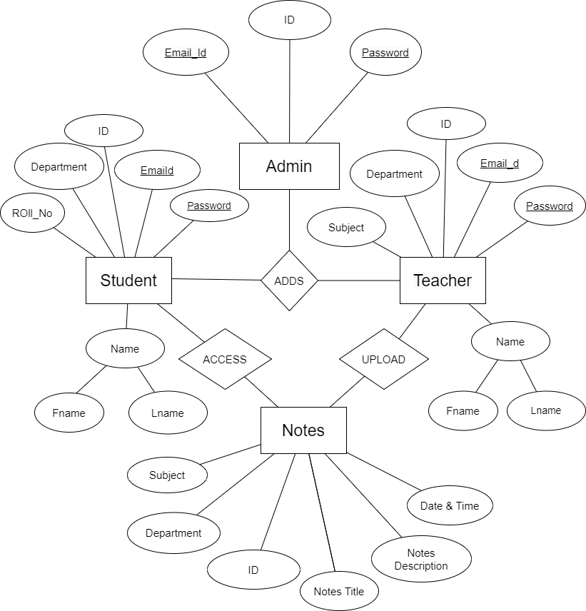

4.4 Data Dictionary
The College Notes Management System web application will utilize the following data entities:
Admin: This entity will store admin id and password
Student: This entity will store information about each student, such as their name, email, and password.
Teacher: This entity will store information about each teacher, such as their name, department, email, and password.
Notes: This entity will store information about each note, such as the class, topic, date, and content of the note.
The data dictionary for each entity is provided below:
Admin
Id (primary key)
Email
Password

Student
Id (primary key)
Fname
Lname
Email
Password
Department
Roll no

Teacher
Id (primary key)
Fname
Lname
Email
Password
Department
Subject
Roll no

Course
Id (primary key)
name

Notes
Id (primary key)
Notes title
Notes description
Subject
Department
Date Time
Teacher Id (Foreign key)

Each entity will have a unique ID as a primary key and will be related to other entities through foreign keys, where appropriate. The data will be stored in a database, and the application will use SQL to access and manipulate the data.

5. Other Non-functional Requirements

5.1 Performance Requirements
The College Notes Management System web application will be designed to perform efficiently and quickly. The application will be able to handle a high volume of concurrent users and will not experience significant delays or downtime.

5.2 Safety Requirements
Backup and Recovery: The system must have a robust backup and recovery mechanism in place to ensure that data is not lost in case of a disaster or system failure.

5.3 Security Requirements

There are several security requirements that should be considered when developing a college notes management system, including:
Integrity: The data entered into the system should be protected from unauthorized modification.
Availability: The system should be designed to ensure that it is always available and accessible to authorized users.
Authentication: Users should be required to provide proof of their identity before accessing the system.
Authorization: Users should only be able to access the information and perform the actions for which they have been granted permission.
Encryption: All sensitive data should be encrypted both in transit and at rest.

5.4 Software Quality Attributes
There are several software quality attributes that should be considered when developing college notes management system
Usability: The College Notes Management System web application will have a user-friendly interface that is easy to navigate. The interface will be designed to be responsive and accessible on any device with internet access.
Scalability: The College Notes Management System web application will be designed to be scalable to accommodate an increasing number of students and teachers over time. The application will be able to handle a high volume of notes and users without experiencing significant performance issues.
Portability: College Notes Management System web application will be accessible via a web browser on any device with internet access. The application will be hosted on a server that is maintained by the college or university, making it easily portable to other institutions.

